Sino Bright School Chongqing
Midterm Exam, 2025-2026 T1
Class & Subject: G10 C1 Math

Date: November 2025

Time: 90 minutes

Teacher Responsible: Shi Feng

IMPORTANT: Read together before beginning the exam.

Students must complete the assessments to the best of their ability. Any students found cheating during an exam will be given a zero and referred to the Principal for further disciplinary measures. Cheating is a serious offense.

“Cheating” may include any of the following:
- Having course papers, notes, unapproved data sheets or other course-related materials in the exam room without the express permission of the subject class teacher in charge of the exam.
- Using or even having a cellphone or other electronic device in the exam room without the express permission of the subject class teacher in charge of the exam.
- Attempting to communicate, either verbally or non-verbally with other students during the exam.
- Having exam-related materials prior to the writing of the exam.

Mark Breakdown:  Total Score:  73 | Student Name：_____________  Score: _____________

Special Instructions/Materials Allowed:
Calculator

Questions
Q1.
(a) Given that 3^{−1.5} = find the exact value of a
(2)
(b) Simplify fully 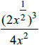
(3)

(Total for question = 5 marks)

Q2.
In this question you must show all stages of your working.
Solutions relying entirely on calculator technology are not acceptable.
The curve C has equation
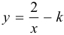
where k is a positive constant.
(a) Sketch the graph of C.
Show on your sketch
• the coordinates of any points of intersection of C with the coordinate axes
• the equation of the horizontal asymptote to C
stating each in terms of k.
(3)
The line l has equation y = −kx − 6
Given that l intersects C at 2 distinct points,
(b) find the range of possible values of k.
(5)

(Total for question = 8 marks)

Q3.
The equation
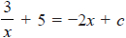
where c is a constant, has no real roots.
Find the range of possible values of c.

(Total for question = 7 marks)

Q4.
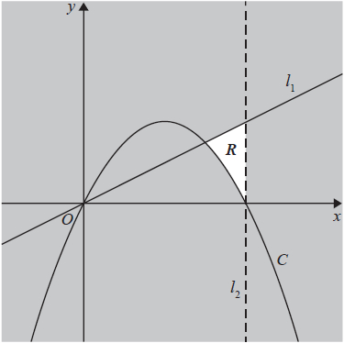
Figure 1
Figure 1 shows a line l₁ with equation 2y = x and a curve C with equation 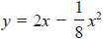
The region R, shown unshaded in Figure 1, is bounded by the line l₁, the curve C and a line l₂
Given that l₂ is parallel to the y-axis and passes through the intercept of C with the positive x-axis, identify the inequalities that define R.

(Total for question = 3 marks)

Q5.
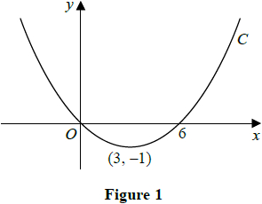
Figure 1 shows a sketch of the curve C with equation y = f(x)
The curve C passes through the origin and through (6, 0)
The curve C has a minimum at the point (3, −1)
On separate diagrams, sketch the curve with equation
(a) y = f(2x)
(3)
(b) y = f(x + p), where p is a constant and 0 < p < 3
(4)
On each diagram show the coordinates of any points where the curve intersects the x-axis and of any minimum or maximum points.

(Total for question = 7 marks)

Q6.
(a) On the same axes, sketch the graphs of y = x + 2 and y = x² − x − 6 showing the coordinates of all points at which each graph crosses the coordinate axes.
(4)
(b) On your sketch, show, by shading, the region R defined by the inequalities
y < x + 2 andy > x² − x − 6
(1)
(c) Hence, or otherwise, find the set of values of x for which x² − 2x − 8 < 0
(3)

(Total for question = 8 marks)

Q7.
Solve the simultaneous equations
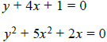

(Total for question = 6 marks)

Q8.
A curve has equation
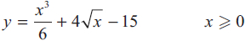
(a) Find , giving the answer in simplest form.
(3)
The point 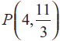 lies on the curve.
(b) Find the equation of the normal to the curve at P. Write your answer in the form ax + by + c = 0, where a, b and c are integers to be found.
(4)

(Total for question = 7 marks)

Q9.
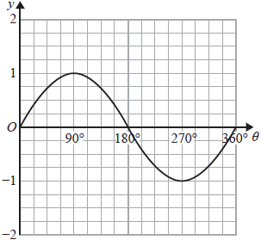
Figure 3
Figure 3 shows a plot of the curve with equation y = sin θ, 0 ≤ θ ≤ 360°
(a) State the coordinates of the minimum point on the curve with equation
y = 4 sin θ, 0 ≤ θ ≤ 360°
(2)
A copy of Figure 3, called Diagram 1, is shown here.
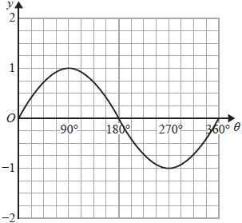
Diagram 1
(b) On Diagram 1, sketch and label the curves
(i) y = 1 + sin θ, 0 ≤ θ ≤ 360°
(ii) y = tan θ, 0 ≤ θ ≤ 360°
(2)
(c) Hence find the number of solutions of the equation
(i) tan θ = 1 + sin θ that lie in the region 0 ≤ θ ≤ 2160°
(i) tan θ = 1 + sin θ that lie in the region 0 ≤ θ ≤ 1980°
(3)

(Total for question = 7 marks)

Q10.
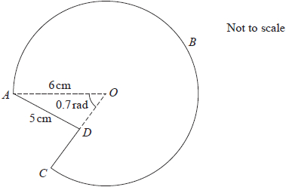
Figure 2
The shape ABCDA consists of a sector ABCOA of a circle, centre O, joined to a triangle AOD, as shown in Figure 2.
The point D lies on OC.
The radius of the circle is 6 cm, length AD is 5 cm and angle AOD is 0.7 radians.
(a) Find the area of the sector ABCOA, giving your answer to one decimal place.
(3)
Given angle ADO is obtuse,
(b) find the size of angle ADO, giving your answer to 3 decimal places.
(3)
(c) Hence find the perimeter of shape ABCDA, giving your answer to one decimal place.
(4)

(Total for question = 10 marks)

